**Time to Tune and Tweak**

**Objective**: In this video, we're going to tune the movement of our rail and our ships so it feels a little bit more like what our game is intended to be, and we can all see how it feels to dodge out of the way of elements at the proper speed.

**When to tune your gameplay**

When something doesn’t feel right you need to tune your gameplay.

We’re moving too fast along our rail. Its really irritating. This is supposed to be a huge world, and yeah I've got a pretty fast ship here but if there's any creatures to shoot it going to be, he's gone.

1. Go to your **Main Camera** and in the **Waypoint Script** look for the **Look Ahead for Target** field. I set mine to 0.13 but try to find the right number so your ship isn’t flying too fast. I also moved some points in my circuit and fixed it up a tiny bit. This is no where near my final circuit I just wanted to make some small adjustments.

Great, again, it kind of feels too slow, doesn't it? So what should we do about this? Speed it up. We could speed it up. But the other thing I'm noticing is, I'm not getting that cool, when you play a racing car game, you get things whizzing past, right?

1. Go to your **camera** and change your **Field of View** to 137 and notice how much faster it looks like we’re going! Even though we know it’s the exact same speed.
2. Okay before we proceed lets save our current window layout for Unity.

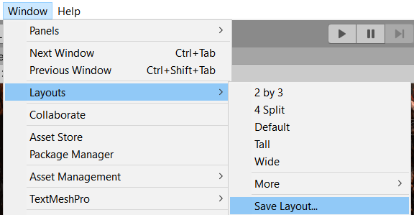

1. Now im going to rearrange the layout for Unity for this particular game and I want you to recreate it. Im also going to go ahead and save this layout as **Scene and Game**

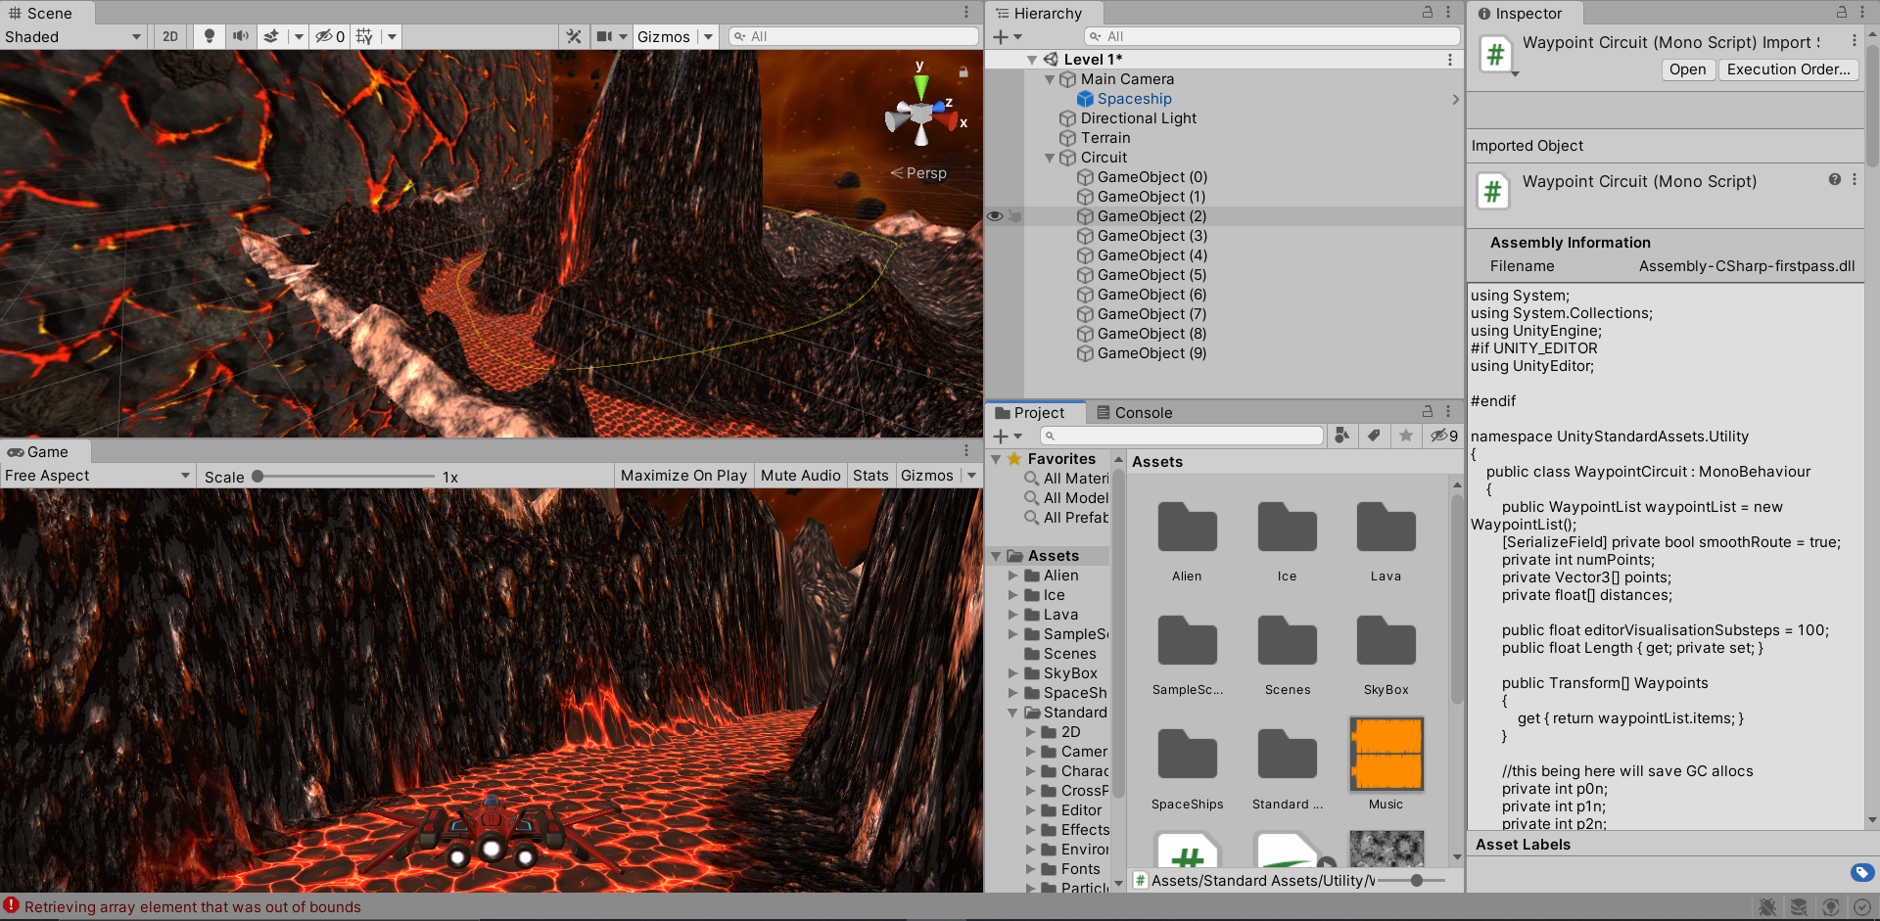

When you click play you should see your rocket move in both screens. If your FOV is still set to a high value you can see how much impact it has in the game view, but in the scene view it’s the same slow ship. Try to find a FOV value that seems to add a good amount of speed to the game. I changed **FOV** to **80** and my **Look Ahead for Target** value to **1.**

Now the caveat I'll say throughout this whole lecture is we're not shooting, we don't have enemies, we don't have our chaos going in yet. So I don't want to over tune at the moment, I just want to get it feeling the next step better and this already feels a lot better then where it was before.

1. Lets change our Game window from **Free Aspect** to **16:9**
2. Lets play our game and move around. What do you notice?? What’s causing my ship from moving to the edge? The Clamping! We need to move the position of our spaceship back a bit closer to the camera.
3. So now our ship feels a bit too fast. ands this goes back to that cycle I mentioned. You make a change and you test it and keep adjusting. Change the Player Script **Speed** value to **10**.I don't want it to feel like if there's an obstacle that I can get out of the way really fast. I want to feel a little of the pressure.
4. Lets change the **X Range** to 6 and the **Y Range** to 4

Now we're not shooting at this, all might change when we actually start shooting it.

1. Finally lets change our **Roll Control Factor** to **-30**

**Challenge:** I want you guys to tweak and tune your ship movement. Spend some time tuning your game in terms of the speed of movement on the rail. Just get it approximate for now. Your camera distance and field of view, the players' speed rotation and clamps so that they don't bounce outside of your screen. Make sure you've got 16:9 selected. And then, some obstacles to avoid, if you want to raise or lower your terrain a little bit, to make sure that you're testing, what happens if there's a big object in the way, and I have to fly around it? You can even put some game objects in the scene if you want, to fly under and over. And then obstacles that you can pretend to shoot.